# Explore and Clean Company Listing Information

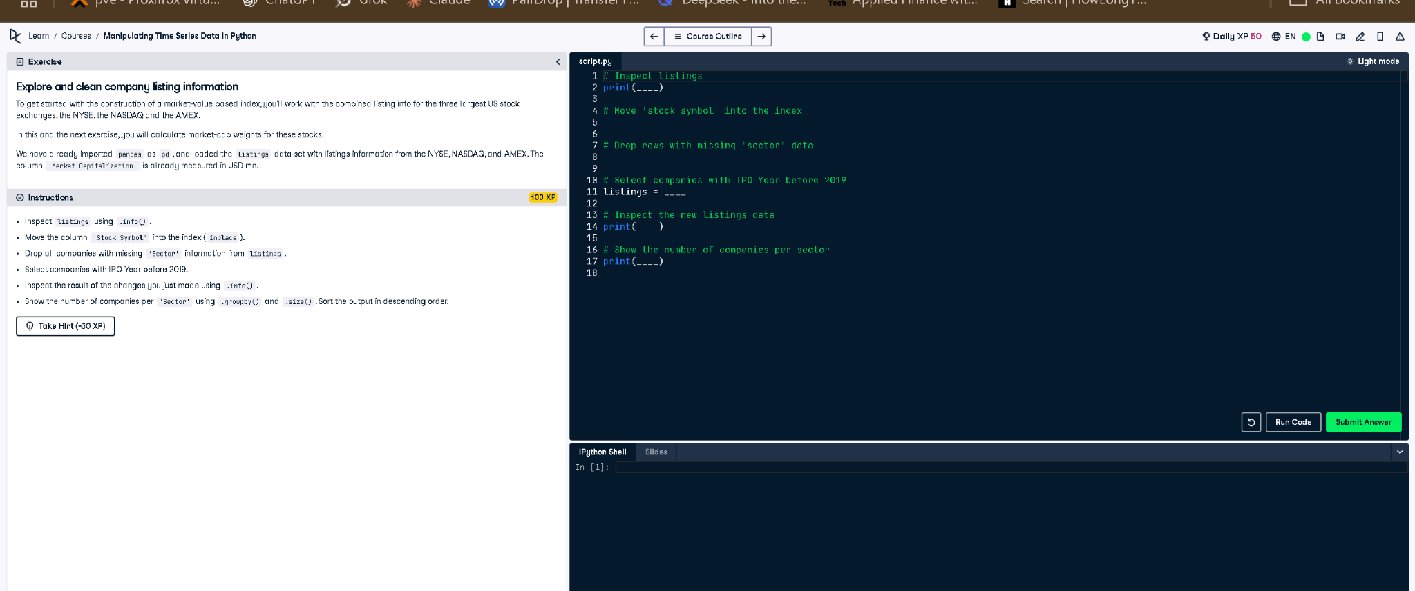

## ✅ Full Correct Code:

# Inspect Listings  
print(listings.info())  
  
# Move 'stock symbol' into the index  
listings.set_index("Stock Symbol", inplace=True)  
  
# Drop rows with missing 'sector' data  
listings.dropna(subset=["Sector"], inplace=True)  
  
# Select companies with IPO Year before 2019  
listings = listings[listings["IPO Year"] < 2019]  
  
# Inspect the new listings data  
print(listings.info())  
  
# Show the number of companies per sector  
print(listings.groupby("Sector").size().sort_values(ascending=False))

## 📘 Explanation (Simple Terms):

This task filters and cleans a company listings dataset. First, we check the structure with .info(), set 'Stock Symbol' as the index, remove rows with missing sector info, and keep only companies with IPOs before 2019. Then, we display updated info and count companies by sector.